Dear Michel,

Thanks again for the discussion of yesterday. I checked my VGT archive for internal consistency as you suggested:

-NDVI ten days composites computed from the original spectral band differs from the one computed by VITO at the 3rd decimal number, I guess it is because of some minor rounding effects (I used double precision data);

- dekads are computed as in Nadine algorithm (the first day of each month is always the first day of the composite).

It could have been worse!

Just to give you an idea of the study area (Niger), please find below a fapar image of the study area and some relevant profiles (note that the Y scale is changing). On the X axis: dekad 1 is the first of 2000, last dekad is the third of 2011.

Profile A) refers to a semi desert area, B) could be sparse vegetation, C) and D) refer to crop. The profile D) shows the typical situation I was describing you yesterday with missing values and negative peaks.



Then, as you suggested, I tried to apply the coefficients published in JRC Publication No. EUR 20146 EN (An optimized FAPAR Algorithm Theoretical Basis Document) to compute the ONVI index on the non-rectified bands I have.

Here the equation I used (0.37598\*float(b2)-0.50132\*float(b1)+0.01091)/((-0.17150-float(b1))^2+(0.29464-float(b2))^2+0.11009), where b2=NIR, and b1=RED) .

I guess I am doing something wrong because I get very low ONVI values .. see below the scatter plot for a subset of the image (Y=fAPAR VITO, X=ONVI).

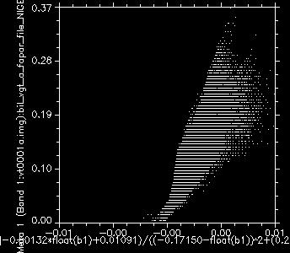

Thanks a lot for your help,

Michele